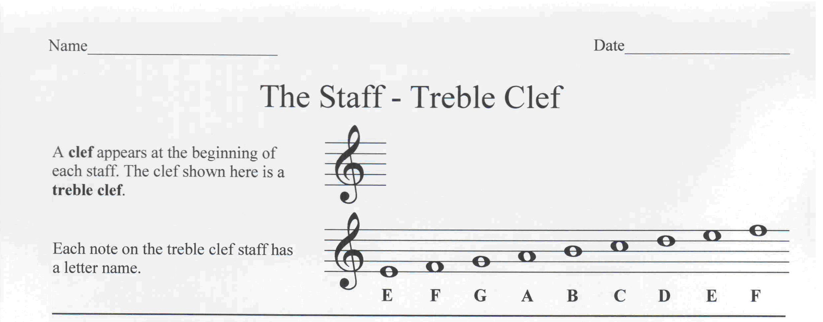
Type in the letter name of each note. Make the text of the lowest note in the row bold
C
F
E
G
A
D
E
F
A
F

Identify each note and make the text of the highest note in each measure bold. Remember measures are separated by bar lines. The first one is an example.

E
G
B
D
F
F
C
D
E
E
G
A

Identify each note and make the text of the lowest note in each measure bold. Remember measures are separated by bar lines. The first one is an example.
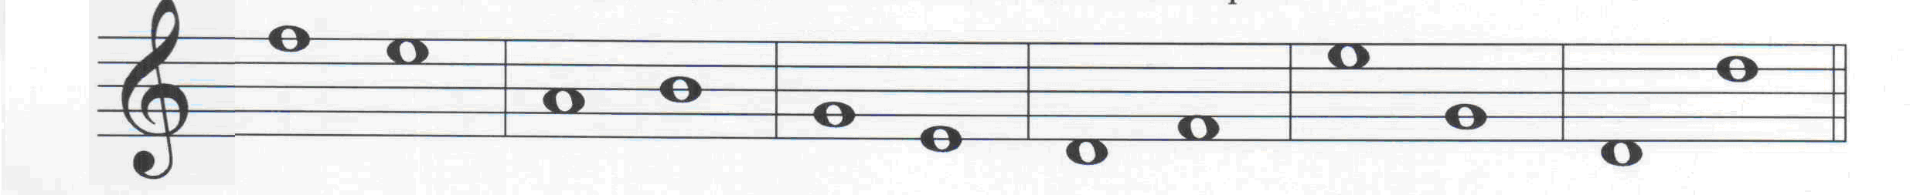
F
E
A
B
G
E
D
F
E
G
D
D

